CO88 – Settlement product cost collector collective

Functionality
During Product Cost Collectors settlement, either WIP (at target cost) or Variance or both are posted.
Through the production process, Product Cost Collectors are debited with actual costs. The actual costs posted to a product cost collector can be more or less than the value with which a product cost collector was credited when the goods receipt was posted. When you settle, this difference between the debit and credit of the product cost collector is transferred to Financial Accounting (FI). Settlement also feeds data from Cost Object Controlling to other components.
The following can happen during the settlement process:
The order balance can be reduced to zero by transferring to Financial Accounting (FI) the difference between the preliminary inventory valuation (goods receipt) and the actual costs incurred. The price difference can also be transferred to Profit Center Accounting (EC-PCA).
The total variance can be transferred to profitability segments in Profitability Analysis (CO-PA). This enables you to see an additional contribution margin in CO-PA. You can transfer the individual variance categories of the total variance to value fields in CO-PA in combination with certain cost elements or cost element groups.

Scenario
You want to post WIP or Variance after WIP and Variance calculation.

Requirements
WIP and Variance was calculated.

Menu Path | Accounting → Controlling → Product Cost Controlling → Cost Object Controlling → Product Cost by Period → Period-End Closing → Single Functions: Product Cost Collector → Settlement → CO88 - Collective Processing → CO88 - Collective Processing
Transaction Code | CO88

1. Double click on CO88 - Collective Processing

Actual Settlement: Production/process orders

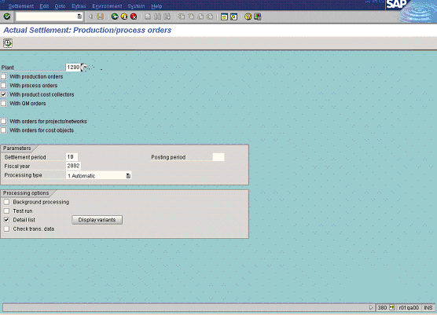

2. Click the With production orders checkbox to deselect.

3. Click the With process orders checkbox to deselect.

4. Click the With QM orders checkbox to deselect.

5. Update the following fields:

Field Name | Field Description | Values
Plant | Code identifying the operational unit of the company where the material is manufactured and stored | Example: 1200
Settlement period | The period in which product cost collectors are to be settled. | Example: 10
Fiscal year | The year in which product cost collectors are to be settled. | Example: 2002

Note: As settlement period differs from posting period you need to specify the posting period in separate field. Such situation can happen due to a requirement of a mistake correction.

6. Click the Test run checkbox to deselect.
7. Click the Detail list checkbox to select.
8. Click the Execute button.
9. Click the Detail list button.

Actual Settlement: Production/process orders Detail list

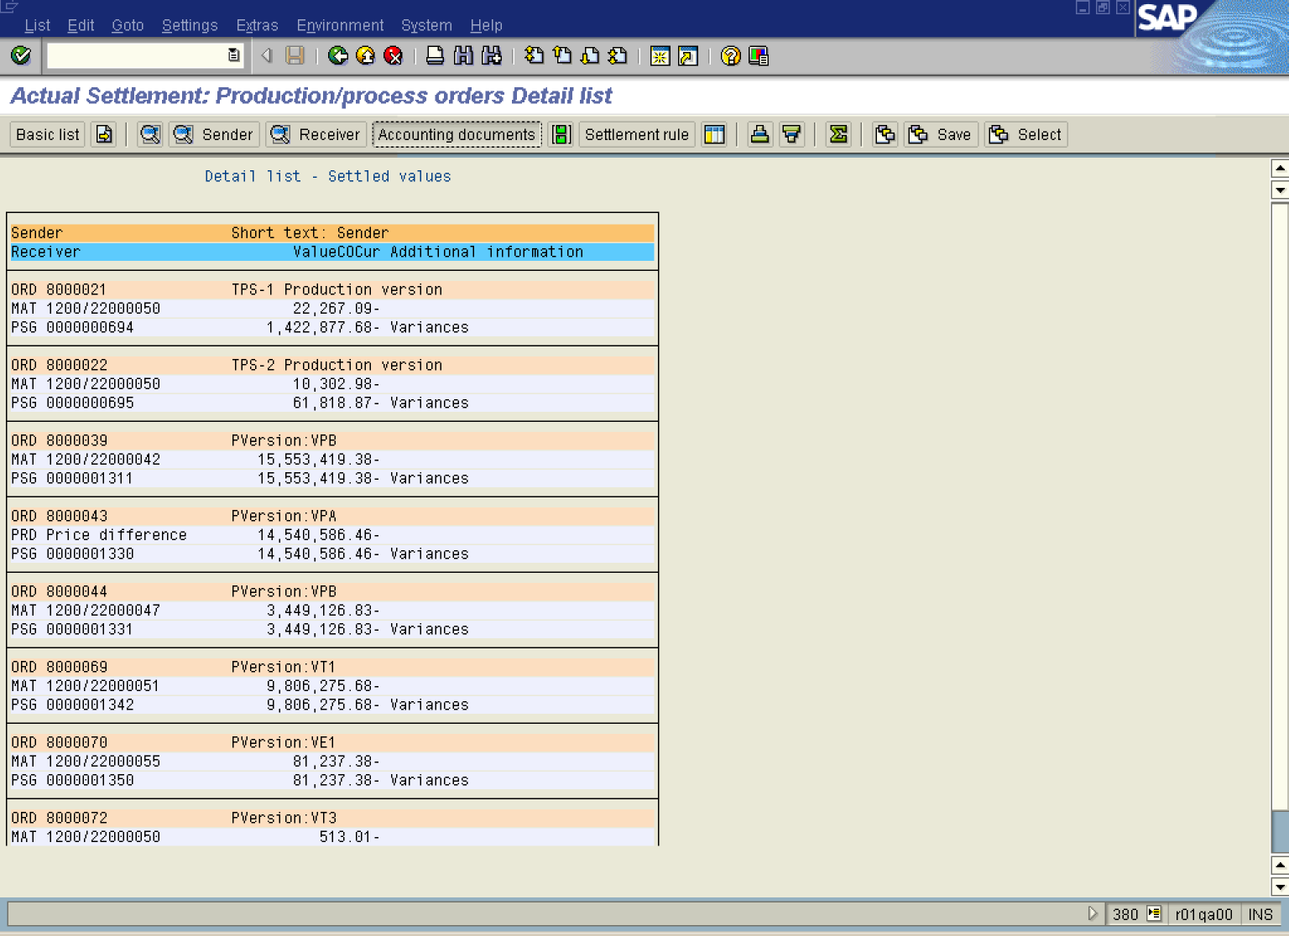

10. Select the ORD 8000021 TPS-1 Production version entry.

11. Click the Accounting documents button.

List of Documents in Accounting

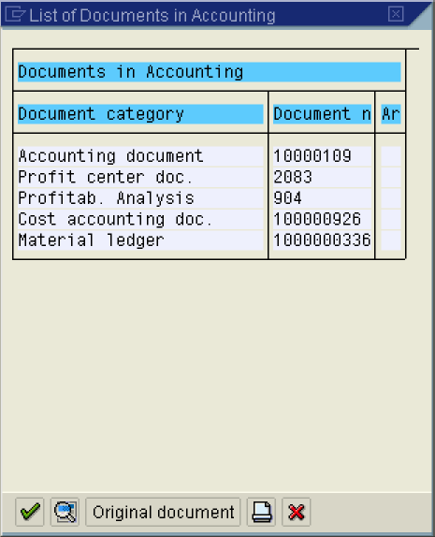

12. Click the Accounting document 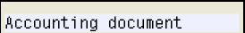 entry.

Display Document: Overview

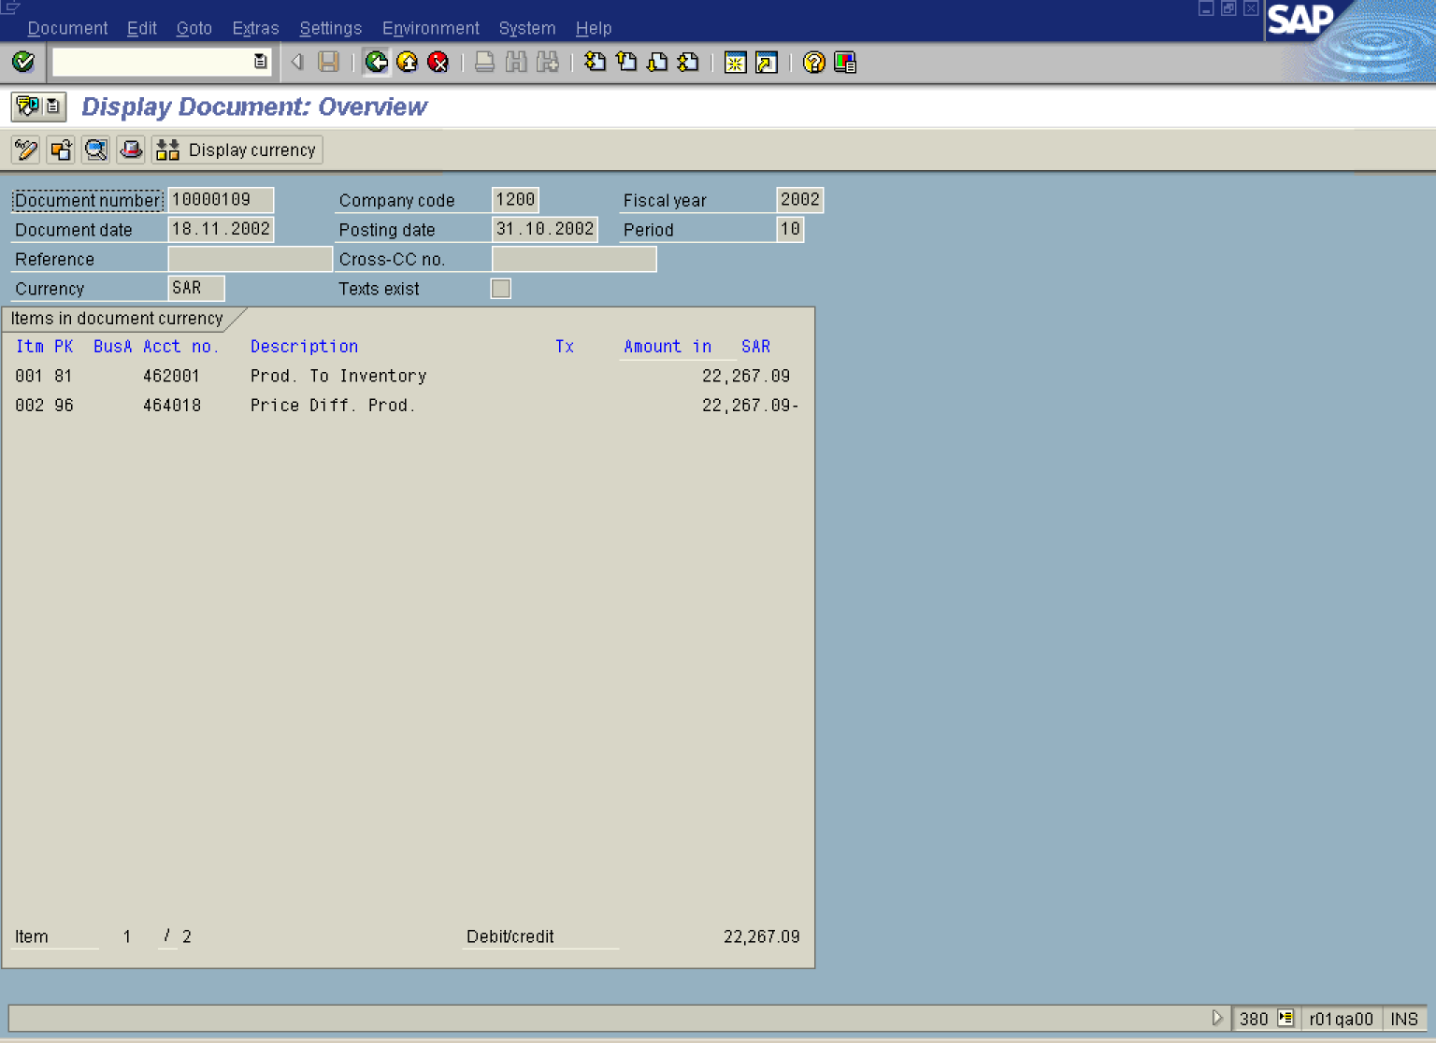

13. Click the Back button.

Actual Settlement: Production/process orders Detail list

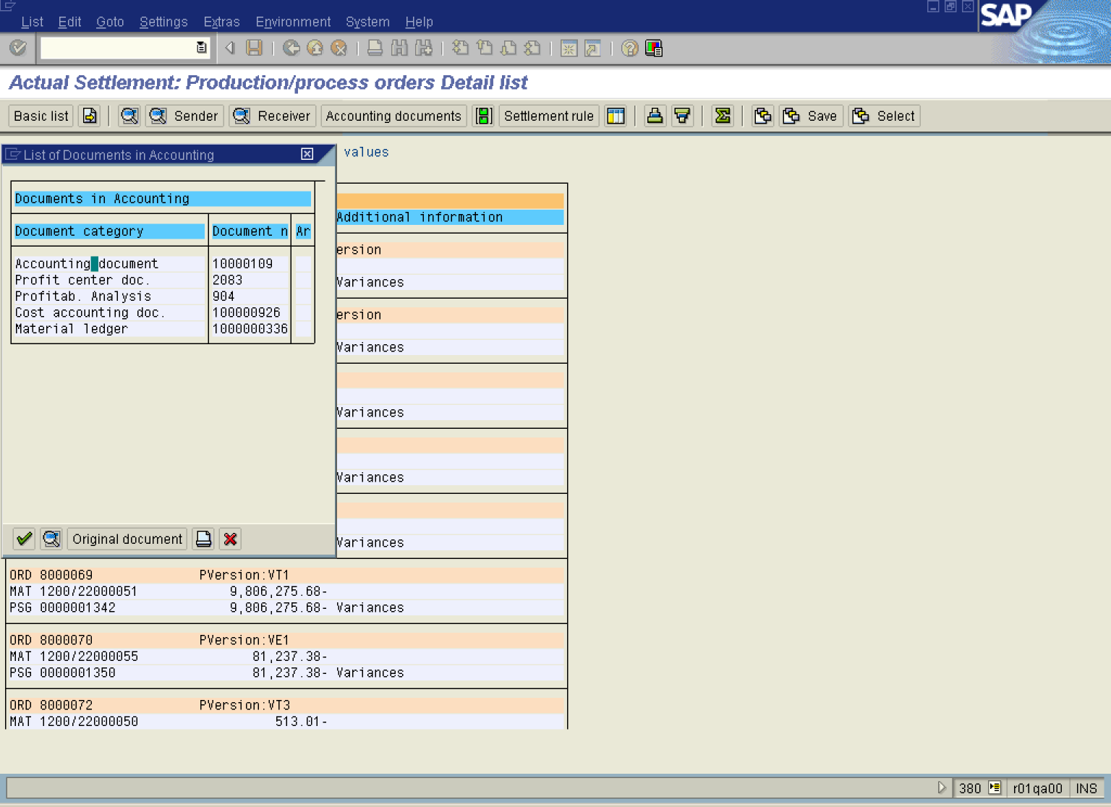

14. Click the Cancel button.

Actual Settlement: Production/process orders Detail list

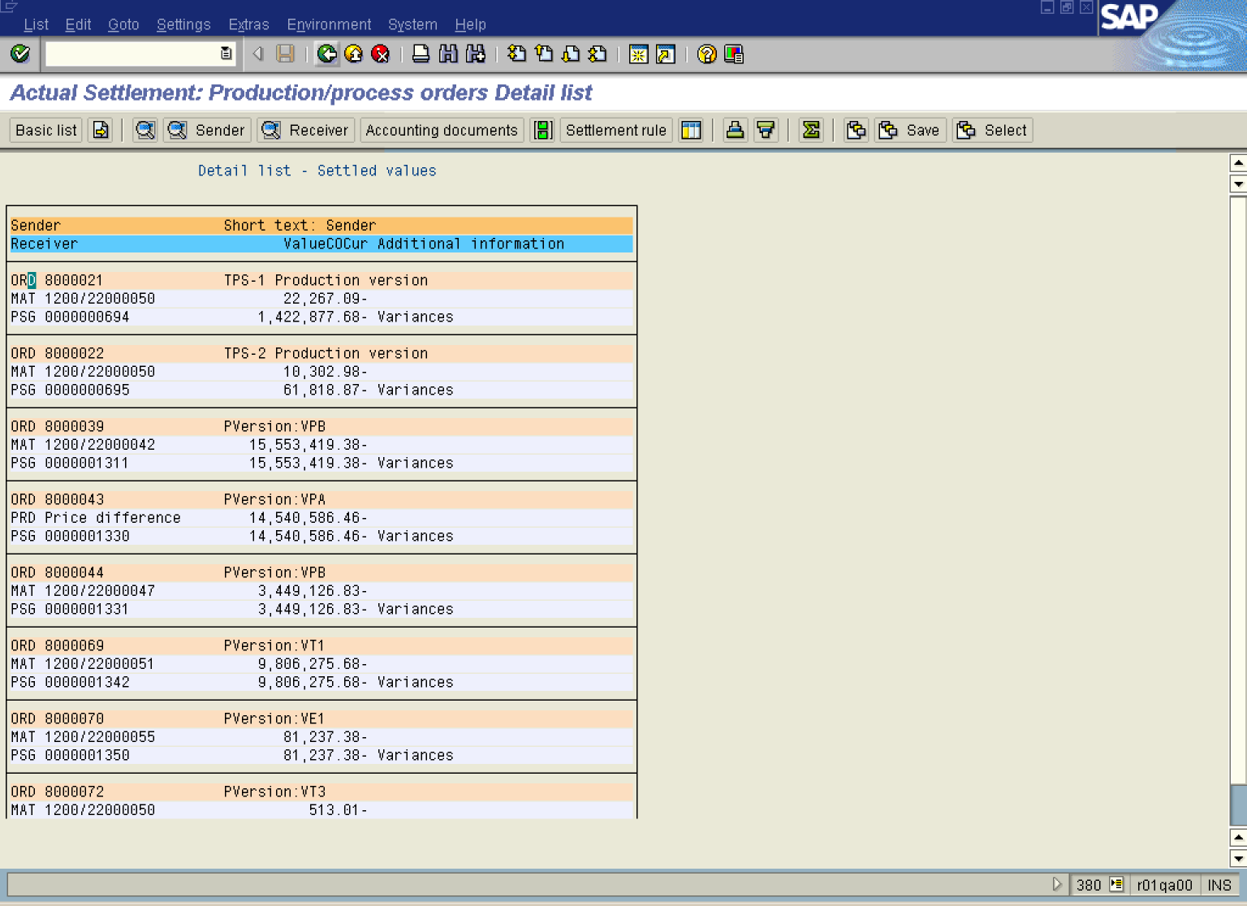

15. Click the Back button.

16. Click the Back button.

